Help Document For Student

    - Understanding of main menu

    - Main Menu

2.1. Home

2.2. Help on Search

2.3. My profile

2.4. My Account

2.4.1 Reserve Book

2.4.1.1 How to reserve Book

2.4.2 Your Current Loan

2.4.3 My Book Request

2.5. Recently Viewed

2.6. My E Self

2.6.1 My Eshelf

2.6.2 Google Docs

2.6.3 Create your Document

    - Search

    - Understanding Of Icons

1.Understanding of Home Page:

The Homepage Contains mainly 6 things, they are
        - Main Menu.
        - Search Option.
        - Notifications.
        - Accordion Menu.
        - Recently Viewed Books.
        - Logout.

The snapshot below Shows the home page .

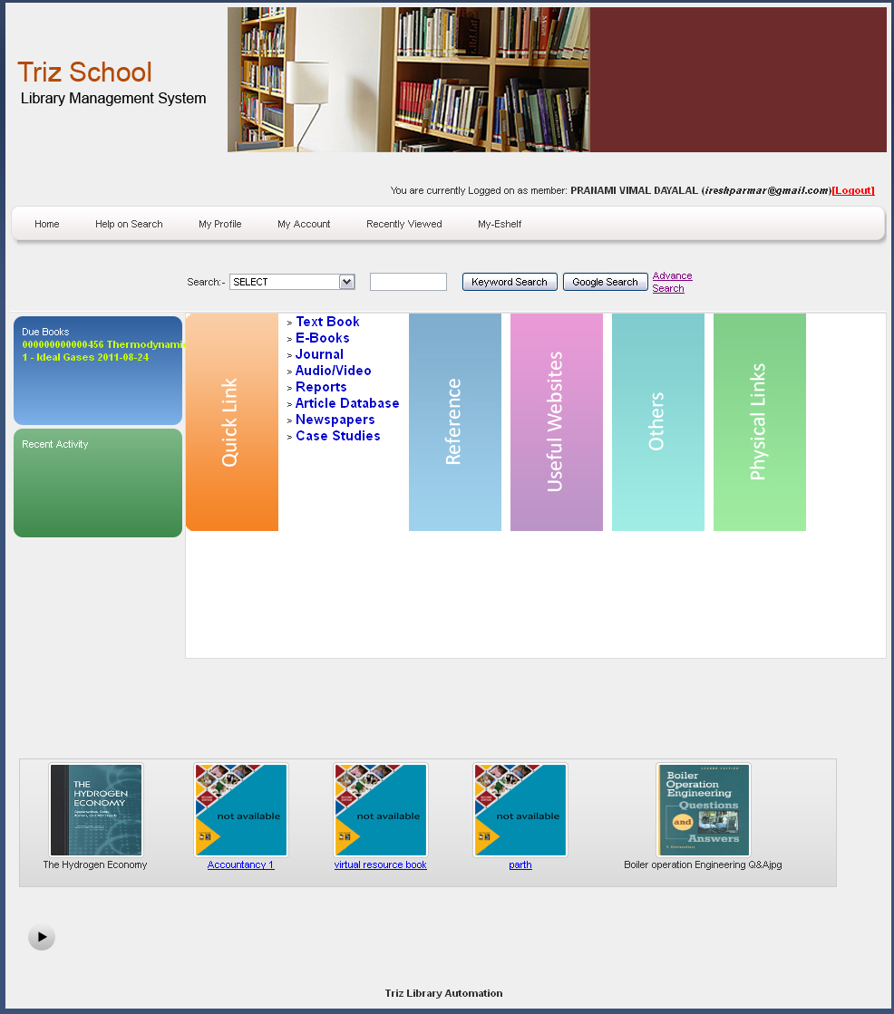
1
2
3
6

Now we will understand each of them.

- Main Menu : This menu is explained later in the document.

- Search option : Is used for searching the book ( catalog) from the book database.
To extend the search criteria “Advanced Search ” option is present with the Search Option.

- Notifications : Shows the notification to the student about “ Due Books” and “Recent Activity ”.

- Accordion Menu : Accordion Menu contains 5 menus. They are

1. Quick Link : Quick links contains the link to the Text Books, E-Books, Journals, Audio/Video etc.

2. Reference : Reference contains the link to the Dictionaries, Directories, Acronyms, Encyclopedia, Databases etc.
4

3. Useful Websites : Useful Websites contains the link to the Career Development, Search Engines, Government, International Education etc.

4. Others : Others links contains the link to the How it works, Hands-on-activities, currency, Reading Mission, Music etc.

5. Physical Links : Physical Links links contains the link to the Magazines, CD, Books, News Paper . This physical link is used to see the resources that are present in the library.

- Recently Viewed Books : Shows the Books that are viewed by the Student.
5
- Logout : To End the session / come out to the Library management system.

2. Main Menu

The main menu Contains the following menus.
        - Home.
        - Help on Search.
        - My Profile.
        - My Account.
        - Recently Viewed.
        - My-E shelf.
        - Ask Librarian.

Now we will understand Each Tab in the Main Menu.

2.1 Home : Home tab is used to see the Home Page. ( We have understand the Home Page )

2.2 Help on Search : Is the help document for the Student.

2.3 My Profile : Is used to see the user profile. The below snap shot / picture shows the My Profile.

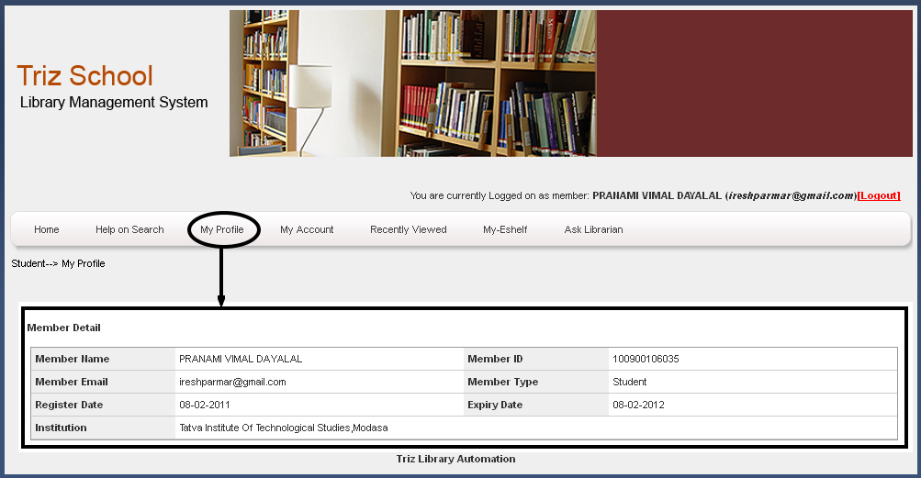
In this profile the fields are not editable the account for the library has to be generated bu the admin of the college.

2.4 My Account :
My Account Tab contains three sub tab. They are
        - Reserve Book.
        - Your Current Loan.
        - My Book Request.

2.4.1. Reserve Book : This Function is used to reserve the book. To make request for reserving the book Click on the link “ Request for Reserve ” as shown in the below snap.
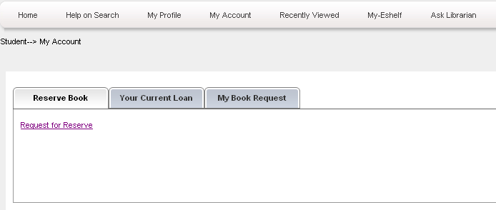

2.4.1.1 - How to Reserve the book :
Note : You can reserve only to those books which are given as a loan to other student and not a single copy of that book is available in the library.
And Can made Request to only Physical resources that are present in the library.
To make a request for reserve first search the book that you want (as a loan )made request. After searching the book look at the availability of that book in the book information below the book.
If the book is available then you can not made the request for reserve. (Then go to the library and loan it from there.) If it shows the availability of book in the library is zero then you can send request for that book by clicking the on the button “ Reserve ” In the book information. On clicking on the Request button the request for that book is send to the Librarian (Administrator) .
The below snap shows how to make a request for reserve.

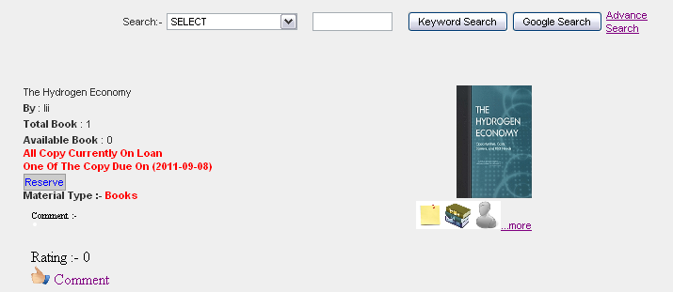

2.4.2. Your Current Loan.: Is showing the Book that you are currently

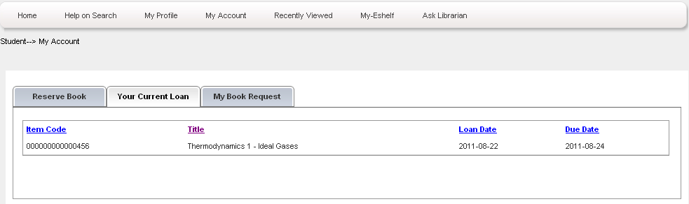
2.4.3. My Book Request.: Shows the Request of the book that you have made to the library system ( Librarian). Is also shows the request status and also contains the button to remove the request.
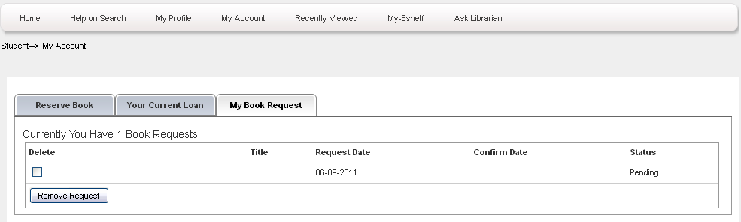

2.5 Recently Viewed : Recently Viewed Menu shows the book that are recently viewed by the student. And it also shows the book information like book name, Author, Total No of books available, the type of the book and book viewed.

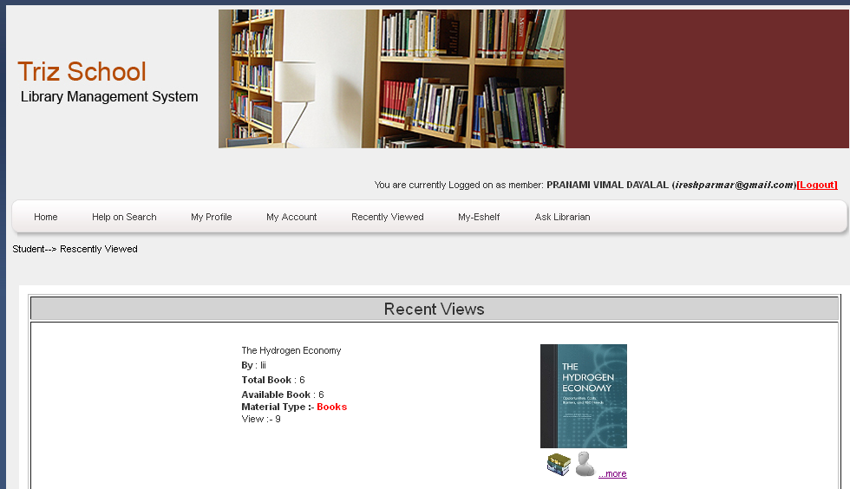
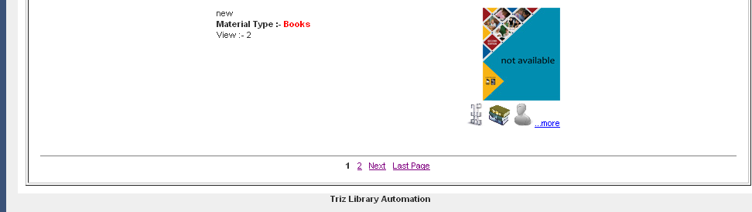

2.6 My-E shelf : My E shelf tab contains the 3 sub tab menus.
    - My-Eshelf
    - Google Docs
    - Create Your Docuyment.

2.6.1 My-Eshelf : You can store your searched books in your shelf. By clicking on the icon below the book. All the icons that are used explained later in the document. The use of this tab is you don't have to search the books again and again
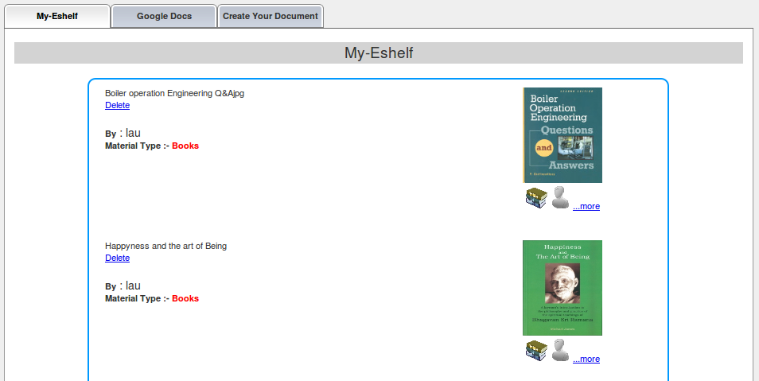
2.6.2 Google Docs : We have a facility of online google documents.

2.6.3 Create Your Document : You can create your own documents if you don't have google account.
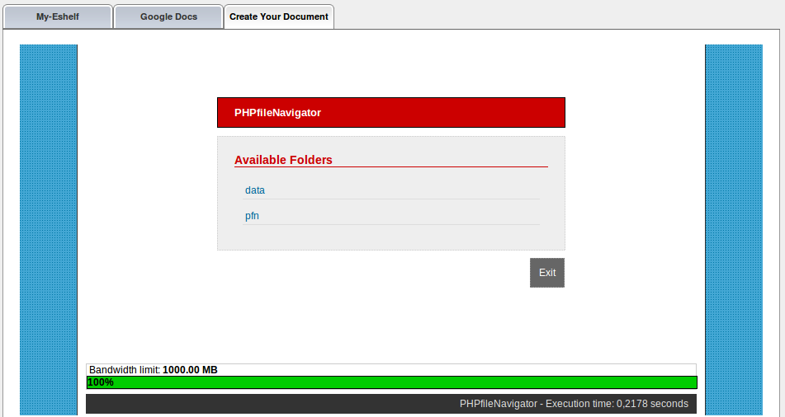

3. Search

There is 2 method available on searching library catalog.
The first one is SIMPLE SEARCH, which is the simplest method on searching catalog, you just enter any keyword, either it contained in document titles, authors name or subjects. You can supply more than one keywords in Simple Search method and it will expanding your search results.
ADVANCED SEARCH, lets you define keywords in more specific fields. If you want your keywords only contained in title field, then type your keyword in Title field and the system will scope it search only on Title field, not in other fields. Location field lets you narrowing search results by specific location, so only collection that exists in selected location get fetched by system.
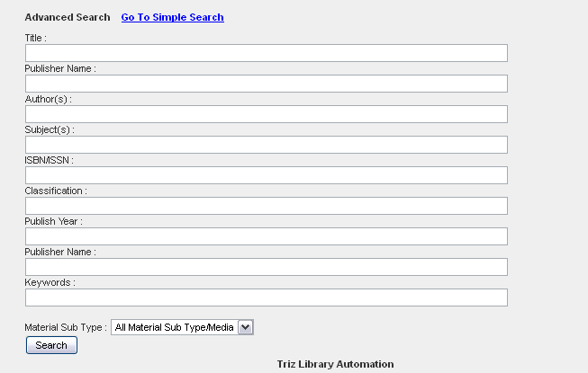

4. Understanding of icons
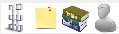
This icon is used to add book to “ My E shelf ”.

Shows the Book Summary.

Shows the table of content for the particular book.

Shows information about Author – Biography.

